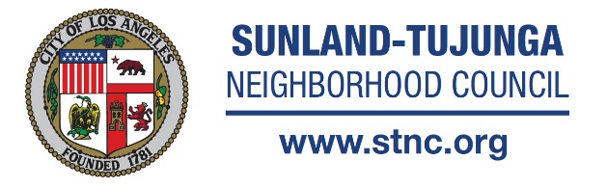
Committee Chair Joe DeCenzo
Committee Members Gerardo Barrientos, Debby Beck,
Lucy Berman, Abby Diamond, Lloyd Hitt, Marlene Hitt,
Dawn Jenkins (Alt), Allan Roman Reyes, Bill Skiles, Corey Stein

QUORUM = 5

Share your voice and get involved: http://www.stnc.org
Stay informed with videos from the STNC Media Team: https://vimeo.com/stnc
Join our Great Streets Team: https://www.facebook.com/SunlandTujungaGreatStreets

Arts, Recreation & Culture Committee Meeting (STARC)
Tuesday, June 6, 2017 @ 7:30 PM

MINUTES (Approved)
In Attendance: Joe DeCenzo, Dawn Jenkins, Lucy Berman, Lloyd Hitt, Marlene Hitt, Gerardo Barrientos, Debby Beck. Guest: Tony Wilkinson

- CALL TO ORDER: Introductions; Approval of Minutes/ Joe DeCenzo: Meeting was convened at 7:44pm. Municipal building was locked. Patti Potter was notified and agreed to deliver keys to allow STARC Committee access to building. Minutes of the May meeting were reviewed. Dawn Jenkins moved to approve minutes as written. Lloyd seconded. Minutes were approved 5-0-1

- PUBLIC COMMENTS: for non-agenda items: Discussion included Community Arts Resource Directory. It was suggested that Melissa Reischman may be able to integrate ideas for website with the existing McGroarty site. If possible, the objective would be to provide a workable framework for artists to submit contact information free of charge with an option to pay a fee of $10 to include photos.

Cindy Cleghorn inquired if there was any interest in participating to update historic brochure “A Journey Into the Past;” further information to follow.

It was decided to move July’s STARC meeting to the 11th as not to conflict with the July 4th holiday.

- UPDATE/DISCUSSION: Council District 7 Election/Tony Wilkinson: Mr. Wilkinson provided encouraging and optimistic comments regarding the election and future swearing in of new city councilmember Monica Rodriguez. He urged committee members to approach her with “Big Pictures” for the future development of the arts in our district. He emphasized that now is a good time to approach her and to develop good relationships with her field deputies in order to gain her attention. He also mentioned the importance of council district 7 to get more involved with people who feel they are not being heard.

- UPDATE/DISCUSSION: McGroarty Arts Center status and upcoming events. Dawn Jenkins encouraged all to attend the upcoming Ceramics show that opened June 3rd and will be running through June 24. She also promoted Burgers, Beer and Bands event opening August 26th. Discussion followed regarding parking and shuttle options for larger events such as the use of VHHS faculty parking lot. Tony Wilkinson brought up the suggestion that McGroarty sponsor a large scale event in another location e.g. under a canopy of trees in a local park to prompt outreach and lure a portion of the community who might not be familiar with the resources of the arts center.

- PLANNING/DISCUSSION: "Hanukkah in the Foothills," Lucy Berman updated committee on the coordination efforts for the upcoming event.

- Review Local Venues And Upcoming Calendar of events: “Only The Oaks Remain” Tuna Canyon Detention Station exhibit will be opening at Bolton Hall Museum July 9 – Aug 9

ADJOURNED AT 9:56PM

